**Capstone Project:**

**Clustering Neighborhoods in Malmö, Sweden**

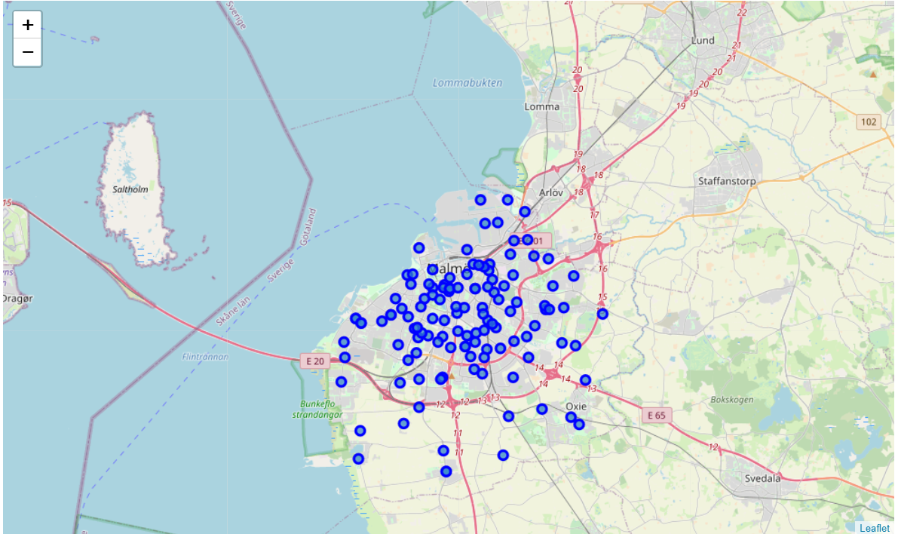

**Introduction/Business Problem**

Opening a New Cafe in the City of Malmö, Sweden.

Malmö is one of the major cities in Sweden, and coffee or *Fika* as we call it in Swedish, is a popular part of the local culture. From Artisan coffee shops to age old traditional coffee shops, cafe's are already popular, and their popularity is growing in the city. Being just 20 minutes across the bridge from the Danish Capital city of Copenhagen, there are a lot of tourists visiting the city all year round.

Since the visiting population is growing and there is potential to open a new coffee shop, there is a need to find the right location for the coffee shop.

How can we find the right set of neighborhoods to start a new café in Malmö?

The idea of this analysis is to understand where are the different coffee shops across Malmö today, and cluster the neighborhoods based on coffee shops and look and compare the data to find the best cluster of neighborhoods to open a new coffee shop.

**Data Section**

The data used will be available from Wikipedia, to find the list of neighborhoods in Malmö City. The dataset consists of the neighborhoods, and using geocoding, we can obtain the locations of them. Foursquare API will be then used to analyze the places in these neighborhoods and see different available venues in these neighborhoods.

**Localities information / Source**: https://en.wikipedia.org/wiki/Category:Neighbourhoods_of_Malm%C3%B6

**Location Provider used:** Foursquare API

"https://api.foursquare.com/v2/venues/explore?client_id=**{}**